1. GitHub ID : LeonGu0402
2. Notes and ideas:

1. Pseudocode:

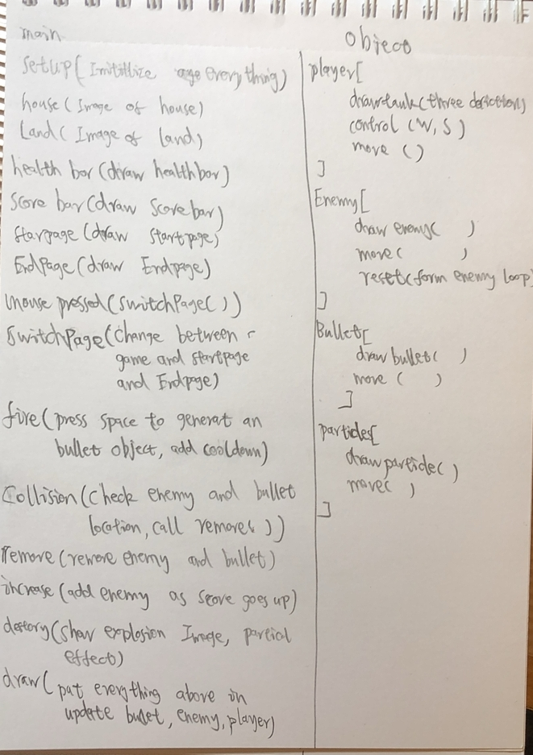

|  |  |  |  |
| --- | --- | --- | --- |
| **Milestone 1** | **Milestone 2** | **Milestone 3** | **Milestone 4** |
| Draw the map, player tank  Make the control system | Health system  Score system  Starting screen and ending screen  Create enemy class  Make enemy move | Create bullet class  Fire function  Collider  Remove enemy and the bullet  Add animation of explosion  Set fail condition and scene switch | Change enemy into arraylist and use array in particles  Increase enemy number as score goes higher  Decorations on map(house)  Use random2d function to create particle effect |
| Shapes1, 2, 3 | System 5, 7, 10 | System 6, 8 | Functions 22, 23 |
| System 4, 9 | Debugging 11 | Loops 16, 17, 18, 19 | List 31, 32, 33 |
| Control flow 15 | Control flow 12, 13, 14 | Functions 20, 21, 24 | Vectors 37, 41, 42, 43 |
| Classes/objects 28, 29, 30 | Functions 21 | Lists 34, 35, 36 |  |
| Vectors 38, 39 | Classes/objects 25, 26, 27 | Vectors 40 |  |
|  |  | Nice to know 45, 48, 49 |  |
|  |  |  |  |
|  |  |  |  |
|  |  |  |  |
|  |  |  |  |
|  |  |  |  |
|  |  |  |  |
| You should deliver approx. 10 skills at this milestone | You should deliver approx. 10 skills at this milestone | You must deliver 30 inventory skills by this milestone. |  |